Local Application Data Store (LADS)
To Business Data Store (BDS)

Operation & Flattening Specification
Table of Contents

1. Modification History 8
2. Document Overview 9
3. Document Assumptions 9
4. BDS Purpose 9
4.1. Pre-BDS Issues 9
5. Standards / Definitions 10
5.1. Column Names 10
5.2. Null SAP Primary Keys 10
5.3. Date Columns 10
5.4. Material, Customer & Vendor Codes 10
5.5. Multi-Language Tables 10
5.6. Sales Area / Distribution Chain Defined 10
6. BDS Flattening 12
6.1. Processing Overview 12
6.2. Execution Overview 12
6.3. Purging 12
7. ATLLAD02 – Stock Balance - (ZOWMIVMX) 13
7.1. LADS Structure 13
7.1.1. Relational Diagram 13
7.1.2. Overview 13
7.1.3. LADS Data Logic 13
7.2. BDS Structure 13
7.2.1. Relational Diagram 13
7.2.2. BDS Logic 13
7.2.3. Tables Explained 13
7.2.3.1. BDS_STOCK_HEADER 13
7.2.3.2. BDS_STOCK_DETAIL 13
ATLLAD04 – Material Master Data - (MATMAS) 14
7.3. LADS Structure 14
7.3.1. Relational Diagram 14
7.3.2. Overview 14
7.3.3. LADS Data Logic 14
7.4. BDS Structure 14
7.4.1. Relational Diagram 15
7.4.2. BDS Logic 15
7.4.3. Tables Explained 16
7.4.3.1. BDS_MATERIAL_HDR – Material Header 16
7.4.3.2. BDS_MATERIAL_DESC – Material Description 16
7.4.3.3. BDS_MATERIAL_MOE – Material Mars Organisational Entity 16
7.4.3.4. BDS_MATERIAL_TEXT – Material Sales Text 16
7.4.3.5. BDS_MATERIAL_TEXT_EN – Material English MVKE Sales Text 16
7.4.3.6. BDS_MATERIAL_TEXT_ZH – Material Chinese MVKE Sales Text 16
7.4.3.7. BDS_MATERIAL_TAX – Material Tax 16
7.4.3.8. BDS_MATERIAL_MOE_GRP – Material Mars Organisational Entity Grouping 17
7.4.3.9. BDS_MATERIAL_DSTRBTN_CHAIN – Material Distribution Chain 17
7.4.3.10. BDS_MATERIAL_UOM – Material Unit of Measure conversions 17
7.4.3.11. BDS_MATERIAL_UOM_EAN – Material Unit of Measure for EAN 17
7.4.3.12. BDS_MATERIAL_REGIONAL – Material Regional Code Conversions 17
7.4.3.13. BDS_MATERIAL_VLTN – Material Regional Code Conversions 17
7.4.3.14. BDS_MATERIAL_PKG_INSTR_HDR – Material Packaging Instruction Header 17
7.4.3.15. BDS_MATERIAL_PKG_INSTR_DET – Material Packaging Instruction Details 17
7.4.3.16. BDS_MATERIAL_PKG_INSTR_EAN – Material Packaging Instruction EAN 18
7.4.3.17. BDS_MATERIAL_PKG_INSTR_MOE – Material Packaging Instruction MOE 18
7.4.3.18. BDS_MATERIAL_PKG_INSTR_TEXT – Material Packaging Instruction Text 18
7.4.3.19. BDS_MATERIAL_PKG_INSTR_REG – Material Packaging Instruction Regional Code Conversions 18
7.4.3.20. BDS_MATERIAL_PLANT_HDR – Material Plant Header 18
7.4.3.21. BDS_MATERIAL_PLANT_FORECAST – Material Plant Forecast data 18
7.4.3.22. BDS_MATERIAL_PLANT_BATCH – Material Plant Warehouse & Batch data 18
7.4.3.23. BDS_MATERIAL_PLANT_VRSN – Material Plant Version 18
7.4.3.24. BDS_MATERIAL_PLANT_UNP_CNSMPTN – Material Plant Unplanned Consumption 19
7.4.3.25. BDS_MATERIAL_PLANT_TTL_CNSMPTN – Material Plant Total Consumption 19
7.4.3.26. BDS_MATERIAL_PLANT_MFANZ – Material/Plant for MFANZ 19
7.4.3.27. BDS_MATERIAL_PLANT_MCH – Material/Plant for MCH 19
ATLLAD06 – Classification Data - (CLFMAS01) 20
7.5. LADS Structure 20
7.5.1. Relational Diagram 20
7.5.2. Overview 20
7.5.3. LADS Data Logic 20
7.6. BDS Structure 20
7.6.1. Relational Diagram 20
7.6.2. BDS Logic 20
7.6.3. Tables Explained 20
7.6.3.1. BDS_MATERIAL_CLASSFCTN 20
7.6.3.2. BDS_CUSTOMER_CLASSFCTN 21
8. ATLLAD08 – Material BOM Data - (BOMMAT03) 22
8.1. LADS Structure 22
8.1.1. Relational Diagram 22
8.1.2. Overview 22
8.1.3. LADS Data Logic 22
8.2. BDS Structure 22
8.2.1. Relational Diagram 22
8.2.2. BDS Logic 22
8.2.3. Tables Explained 22
8.2.3.1. BDS_MATERIAL_BOM_HDR 22
8.2.3.2. BDS_MATERIAL_BOM_DET 22
9. ATLLAD10 – Reference Data - (ZDISTR) 23
9.1. LADS Structure 23
9.1.1. Relational Diagram 23
9.1.2. Overview 23
9.1.3. LADS Data Logic 24
9.2. BDS Structure 25
9.2.1. Relational Diagram 25
9.2.2. BDS Logic 25
9.2.3. Tables Explained 25
9.2.3.1. BDS_REFRNC_PLANT 25
9.2.3.2. BDS_REFRNC_ACCT_ACCT_ASSGNMNT_GRP 26
9.2.3.3. BDS_REFRNC_CHARISTIC 26
9.2.3.4. BDS_REFRNC_MOE 26
9.2.3.5. BDS_REFRNC_BOM_ALTRNT_T415A 26
9.2.3.6. BDS_REFRNC_MATERIAL_TDU & BDS_REFRNC_MATERIAL_ZREP 26
9.2.3.7. BDS_REFRNC_PURCHASING_SRC 26
9.2.3.8. BDS_REFRNC_PRODCTN_RESRC_HDR & BDS_REFRNC_PRODCTN_RESRC_TEXT 26
10. ATLLAD11 – Customer Master Data - (DEBMAS05) 28
10.1. LADS Structure 28
10.1.1. Relational Diagram 28
10.1.2. Overview 28
10.1.3. LADS Data Logic 28
10.2. BDS Structure 28
10.2.1. Relational Diagram 28
10.2.2. BDS Logic 29
10.2.3. Tables Explained 29
10.2.3.1. BDS_CUST_HEADER 29
10.2.3.2. BDS_CUST_TEXT 29
10.2.3.3. BDS_CUST_CONTACT 29
10.2.3.4. BDS_CUST_BANK 29
10.2.3.5. BDS_CUST_UNLPNT 29
10.2.3.6. BDS_CUST_VAT 29
10.2.3.7. BDS_CUST_SALES_AREA 30
10.2.3.8. BDS_CUST_SALES_AREA_VMITYP 30
10.2.3.9. BDS_CUST_SALES_AREA_VMIFCT 30
10.2.3.10. BDS_CUST_SALES_AREA_PNRFUN 30
10.2.3.11. BDS_CUST_SALES_AREA_TAXIND 30
10.2.3.12. BDS_CUST_SALES_AREA_LICSE 30
10.2.3.13. BDS_CUST_SALES_AREA_TEXT 30
10.2.3.14. BDS_CUST_COMP 31
10.2.3.15. BDS_CUST_COMP_WHTAX 31
10.2.3.16. BDS_CUST_COMP_TEXT 31
10.2.3.17. BDS_CUST_PLANT 31
10.2.3.18. BDS_CUST_PLANT_RCVPNT 31
10.2.3.19. BDS_CUST_PLANT_DEPT 31
10.2.3.20. BDS_CUST_PLANT_VOMD 31
10.2.3.21. BDS_CUST_PLANT_VOMD_EXCEPT 32
10.3. LADS Structure 33
10.3.1. Relational Diagram 33
10.3.2. Overview 33
10.3.3. LADS Data Logic 33
10.4. BDS Structure 33
10.4.1. Relational Diagram 33
10.4.2. BDS Logic 33
10.4.3. Tables Explained 33
10.4.3.1. BDS_ADDR_HEADER 33
10.4.3.2. BDS_ADDR_COMMENT 33
10.4.3.3. BDS_ADDR_DETAIL 34
10.4.3.4. BDS_ADDR_EMAIL 34
10.4.3.5. BDS_ADDR_FAX 34
10.4.3.6. BDS_ADDR_PHONE 34
10.4.3.7. BDS_ADDR_URL 34
10.4.3.8. BDS_ADDR_CUSTOMER 34
10.4.3.9. BDS_ADDR_VENDOR 34
11. ATLLAD17 – Factory BOM Data - (LOIBOM01) 36
11.1. LADS Structure 36
11.1.1. Relational Diagram 36
11.1.2. Overview 36
11.1.3. LADS Data Logic 36
11.2. BDS Structure 36
11.2.1. Relational Diagram 36
11.2.2. BDS Logic 36
11.2.3. Tables Explained 36
11.2.3.1. BDS_BOM_HDR 36
11.2.3.2. BDS_BOM_DET 36
12. ATLLAD19 – Vendor Master Data - (CREMAS04) 37
12.1. LADS Structure 37
12.1.1. Relational Diagram 37
12.1.2. Overview 37
12.1.3. LADS Data Logic 37
12.2. BDS Structure 37
12.2.1. Relational Diagram 37
12.2.2. BDS Logic 37
12.2.3. Tables Explained 37
12.2.3.1. BDS_VEND_HEADER 37
12.2.3.2. BDS_VEND_TEXT 38
12.2.3.3. BDS_VEND_BANK 38
12.2.3.4. BDS_VEND_COMP 38
12.2.3.5. BDS_VEND_COMP_WHTAX 38
12.2.3.6. BDS_VEND_COMP_TEXT 38
12.2.3.7. BDS_VEND_COMP_MARS 38
12.2.3.8. BDS_VEND_PURCH 38
12.2.3.9. BDS_VEND_PURCH_PLANT 39
12.2.3.10. BDS_VEND_PURCH_TEXT 39
13. ATLLAD21 – Characteristic Master Data - (CHRMAS03) 40
13.1. LADS Structure 40
13.1.1. Relational Diagram 40
13.1.2. Overview 40
13.1.3. LADS Data Logic 41
13.2. BDS Structure 41
13.2.1. Relational Diagram 41
13.2.2. BDS Logic 41
13.2.3. Tables Explained 42
13.2.3.1. BDS_CHARISTIC_HDR 42
13.2.3.2. BDS_CHARISTIC_VALUE 42
13.2.3.3. BDS_CHARISTIC_VALUE_EN 42
13.2.3.4. BDS_CHARISTIC_DESC 42
14. ATLLAD23 – Stock Intransit - (CTL_ZOU_INTRANSIT) 43
14.1. LADS Structure 43
14.1.1. Relational Diagram 43
14.1.2. Overview 43
14.1.3. LADS Data Logic 43
14.2. BDS Structure 43
14.2.1. Relational Diagram 43
14.2.2. BDS Logic 43
14.2.3. Tables Explained 43
14.2.3.1. BDS_INTRANSIT_HEADER 43
14.2.3.2. BDS_INTRANSIT_DETAIL 43
15. BDS Views 44
15.1. BDS_CUSTOMER_CLASSFCTN_EN 44
15.1.1. Description 44
15.1.2. Source Tables 44
15.1.3. Filters/Logic 44
15.2. BDS_MATERIAL_CLASSFCTN_EN 44
15.2.1. Description 44
15.2.2. Source Tables 44
15.2.3. Filters/Logic 44
15.3. BDS_ ACCT_ASSGNMNT_GRP_EN 44
15.3.1. Description 44
15.3.2. Source Tables 44
15.3.3. Filters/Logic 44
15.4. BDS_MATERIAL_BOM_SYSDATE 44
15.4.1. Description 44
15.4.2. Source Tables 44
15.4.3. Filters/Logic 44
15.5. BDS_MATERIAL_BOM_ALL 45
15.5.1. Description 45
15.5.2. Example Usage 45
15.6. BDS_BOM_ALL 45
15.6.1. Description 45
15.6.2. Example Usage 45
15.6.3. Source Tables 45
15.6.4. Filters/Logic 45
15.7. BDS_MATERIAL_DTRMNTN_SYSDATE 45
15.7.1. Description 45
15.7.2. Source Tables 45
15.7.3. Filters/Logic 45
15.8. BDS_MATERIAL_DTRMNTN_ALL 46
15.8.1. Description 46
15.8.2. Source Tables 46
15.8.3. Filters/Logic 46
15.9. BDS_MATERIAL_PKG_INSTR_SYSDATE 46
15.9.1. Description 46
15.9.2. Source Tables 46
15.9.3. Filters/Logic 46
15.10. BDS_MATERIAL_PKG_INSTR_ALL 46
15.10.1. Description 46
15.10.2. Source Tables 46
15.10.3. Filters/Logic 46
15.11. BDS_PRODCTN_RESRC_EN 46
15.11.1. Description 46
15.11.2. Source Tables 46
15.11.3. Filters/Logic 47
15.12. BDS_ADDR_CUSTOMER_EN 47
15.12.1. Description 47
15.12.2. Source Tables 47
15.12.3. Filters/Logic 47
15.13. BDS_ADDR_VENDOR_EN 47
15.13.1. Description 47
15.13.2. Source Tables 47
15.13.3. Filters/Logic 47
15.14. BDS_STOCK_BALANCE 47
15.14.1. Description 47
15.14.2. Source Tables 47
15.14.3. Filters/Logic 47
16. BDS Functions 48
16.1. Package : BDS_DATE 48
16.1.1. Function : BDS_TO_DATE ( DATE_TYPE, DATE STRING, DATE FORMAT ) 48
16.2. BDS_MATERIAL 48
16.2.1. Function : GET_MATERIAL_BOM 48
16.2.2. Function : GET_UOM_CODE_CONV 48
16.3. BDS_BOM 48
16.3.1. Function : GET_DATASET 48
16.3.2. Function : GET_HIERARCHY 49

Modification History

Date | Version | Description | Reviser
14th November, 2006 | 1.0 | Original | Linden Glen
20th December, 2006 | 2.0 | Updated ATLLAD04 – Material  Included ATLLAD10 – Reference  Updated BDS Processing | Linden Glen
15th January, 2007 | 3.0 | Added ATLLAD08 – Finished Goods BOM  Updated ATLLAD10 – Reference  Added BDS_MATERIAL_PLANT_MFANZ | Linden Glen
25th January, 2007 | 3.1 | Added Function : GET_UOM_CODE_CONV  Updated ATLLAD10 – Reference  Updated/Added Views | Linden Glen
1st March, 2007 | 3.2 | Added ATLLAD17 – Factory BOM | Steve Gregan
21st March, 2007 | 3.3 | Added ATLLAD11 – Customer  Added ATLLAD15 – Address  Added ATLLAD16 – Vendor  Added ATLLAD02 – Stock Balance  Added ATLLAD23 – Intransit Stock | Steve Gregan

Document Overview

This document explains the Local Application Data Store (LADS) and Business Data Store (BDS) structures, including any logic applied to data when loading into either. It’s primary audience is to those wishing to access data via the BDS, but can also be used to gain an understanding of the source LADS data if necessary.

The following areas are covered:

- LADS Table structure & load logic applied (by interface)
- BDS Table structure & processing logic applied (by interface)
- BDS data access explained (by interface)
- Standards used in BDS processing and structures

Document Assumptions

- Reader has a basic understanding of Oracle tables, views and SQL.
- Reader can interpret basic relational diagrams.
- Reader (at minimum) has a high level knowledge of data being dealt with (from a business perspective).

BDS Purpose

The LADS table structure represents IDOC segments received from SAP, which are non-relational. Due to this structure, applications attempting to access LADS data have to include a number of complex joins and logic. The BDS overcomes this, by providing the data in a physical relational structure. The primary goals of the BDS are:

- Fast and logical access to business data for applications (including ability to perform Oracle “fast refreshes” to factory/plant systems).
- Single and centralised point of data join/processing logic.
- Meaningful (relational) physical structure to SAP data.

As a result of these goals, applications should no longer require LADS materialised views (as have been used previously).

Pre-BDS Issues
- Materialised views (running within the LADS DB) over LADS tables were full refreshes due to complex nature of underlying joins. Therefore, at points in time, the target would be empty as the materialised view re-built it. If an application performed a select from the target at that point in time, an empty data set would be returned. The largest impact of this was to the factory, where material data is critical to operation.
- Due to the full refresh nature of the materialised views, and the large amount of data being processed, performance and snapshot space on the database would be impacted whilst they executed. e.g. other applications executing at the same time as a refresh occurred would see “snapshot too old”.
- In some cases, views over LADS data had been created in an iterative manner (views on views) in order to apply various join logic. Due to the joins being applied at each level, the end view would usually be quite slow.
- In several cases, common join/filter logic was applied across multiple views and applications, making upgrades/logic changes difficult. It also created the risk of different results in varying applications.

Standards / Definitions

Column Names
- BDS columns that have not come directly from a LADS column, or where any processing logic is applied will begin with “BDS_”. This represents that data in these columns haven’t been mapped directly from LADS.

Null SAP Primary Keys
It is possible for the SAP primary key fields to arrive at LADS with null values. As the BDS process moves the data into a relational structure, it is necessary to use the SAP primary keys – although null values are not allowed for a primary key column. To overcome this, SAP Primary Key fields that are null default to *NONE.

Date Columns
Date fields within LADS are stored as characters (typically, but not always) in the format YYYYMMDD. To ensure consistency within the BDS, these values will be converted into Oracle dates. The conversion logic will be as follows.

- Date Range Columns
For start_date use 1900/01/01 when null or 00000000
For end_date use 9999/12/31 when null or 00000000
- Standalone Date Columns
Use null if null or 00000000
- Invalid Date/Format
If the date conversion fails using the supplied format mask, then the BDS function attempts to apply other format masks. The additional conversion format masks used are : yyyymmdd, ddmmyyyy, mmddyyyy.
If only one is successful, that mask is used for the conversion. If more than one mask is successful or all fail, then raise alert and fail BDS processing for document (ie. if to_date conversion fails).
This logic is applied via the function BDS_DATE.BDS_TO_DATE – see Functions below for details.

Material, Customer & Vendor Codes
Will not trim leading ‘0’, this can be achieved by the applications as required.

Multi-Language Tables
Where a table contains records by language, the LADS SPRAS_ISO field was used to determine language as opposed to the SPRAS column, which is also commonly available.

Sales Area / Distribution Chain Defined
A Sales Area in SAP is the combination of Sales Organisation / Distribution Channel / Division.
(Customer is typically by Sales Area)
A Distribution Chain in SAP is the combination of Sales Organisation / Distribution Channel.
(Material is typically Distribution Chain)

BDS Flattening

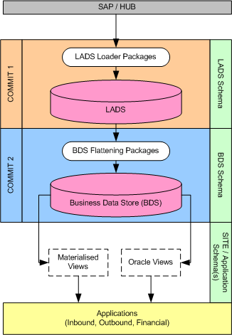
Processing Overview
Data flow from SAP/Hub to Site Applications (via BDS)
- BDS processing is automatically triggered after a successful load into LADS.
- LADS and BDS processing are within individual commit boundaries. i.e. if BDS processing fails for a record, the record will still be committed within LADS and an alert raised.
- BDS processing occurs by interface. There is no cross interface processing. To achieve a cross interface combination of data, views over BDS tables have been used.
- Each LADS header table with an equivalent BDS structure has a LADS_FLATTENED column. This represents the status of this record in relation to the BDS, where the values are as follows : 0 = Unflattened/Unprocessed, 1 = Flattened/Processed, 2 = Skipped/Excluded.

Execution Overview
Each BDS interface can be executed in one of four ways. The Data Warehouse Team controls all execution methods.
*DOCUMENT - this is considered “normal” operation. When a document is successfully loaded into LADS the BDS flattening is automatically triggered. This execution type assumes the parent process (the LADS loader) handles the locking/commit.
*DOCUMENT_OVERRIDE - this execution type can be called manually to reprocess a document. This type makes the BDS processing handle the locking/commit.
*REFRESH – this execution type will process all LADS records that have an unflattened status. It would potentially be used if a BDS processing issue occurred and a number of documents needed processing. This type makes the BDS processing handle the locking/commit.
*REBUILD – this execution type will truncate target BDS tables and reprocess all LADS documents. If using this execution type, ICS Jobs should be stopped, and site application teams notified that BDS tables will be “rebuilt”. This type makes the BDS processing handle the locking/commit.

Purging
BDS tables will be purged based on the same rules used for purging their equivalent LADS tables. Generally, Reference and GRD data is not purged, whereas transactional data (at time of writing) is purged after 3 periods (or 90 days).

ATLLAD02 – Stock Balance - (ZOWMIVMX)

LADS Structure

Relational Diagram

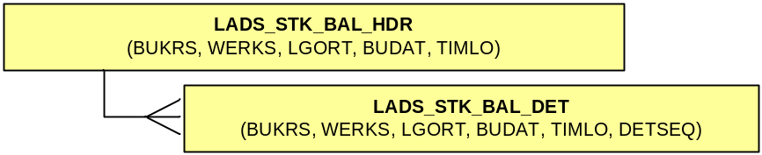

Overview
The Stock Balance interface contains the inventory balance at a point in time for the individual plants.

This is snapshot data, and is purged from LADS.

LADS Data Logic
None applied to this interface.

BDS Structure

Relational Diagram

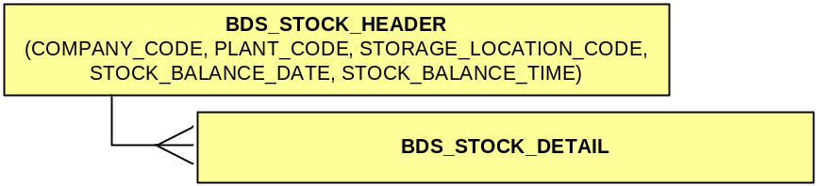

BDS Logic
- None applied to this interface.

Tables Explained

BDS_STOCK_HEADER
Source LADS Tables: LADS_STK_BAL_HDR
Filters: None

Stores Parent level Stock Balance data. The BDS_STOCK_BALANCE view provides a consolidated view of this data with the intransit balances.

BDS_STOCK_DETAIL
Source LADS Tables: LADS_STK_BAL_DET
Filters: None

Stores Child level Stock Balance data.

ATLLAD04 – Material Master Data - (MATMAS)

LADS Structure

Relational Diagram

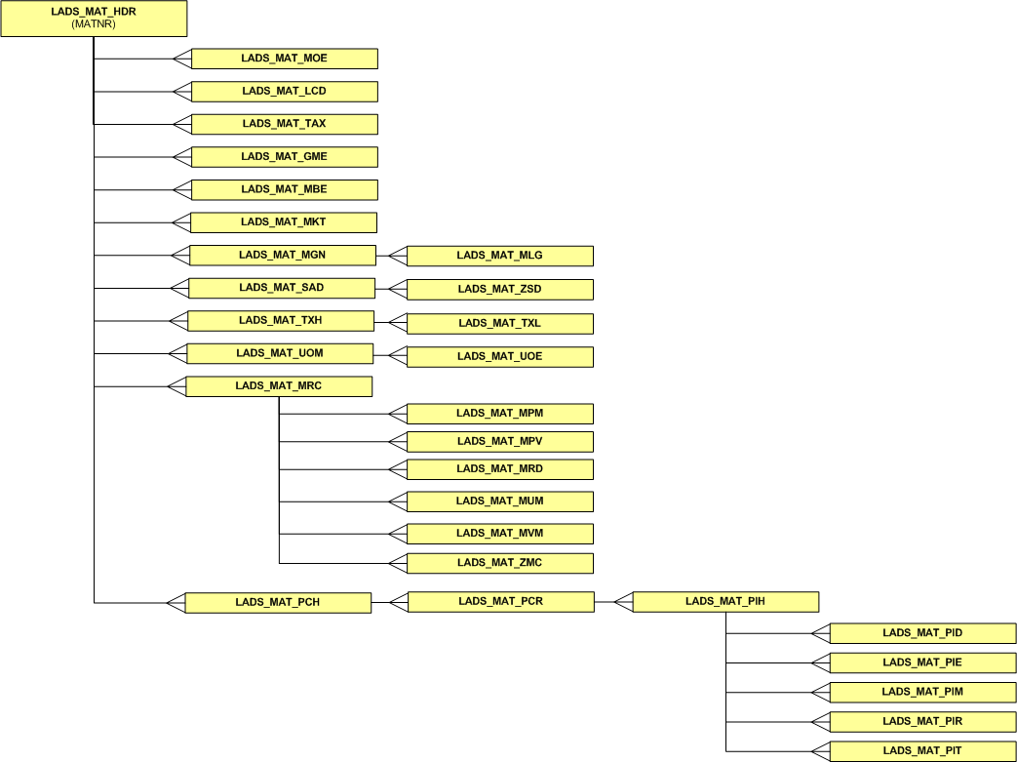

Overview
The material interface contains master data by material, such as packaging instructions, descriptions, unit of measure conversions, etc. This is reference data, and is therefore not purged from LADS.

LADS Data Logic
None applied to this interface.

BDS Structure

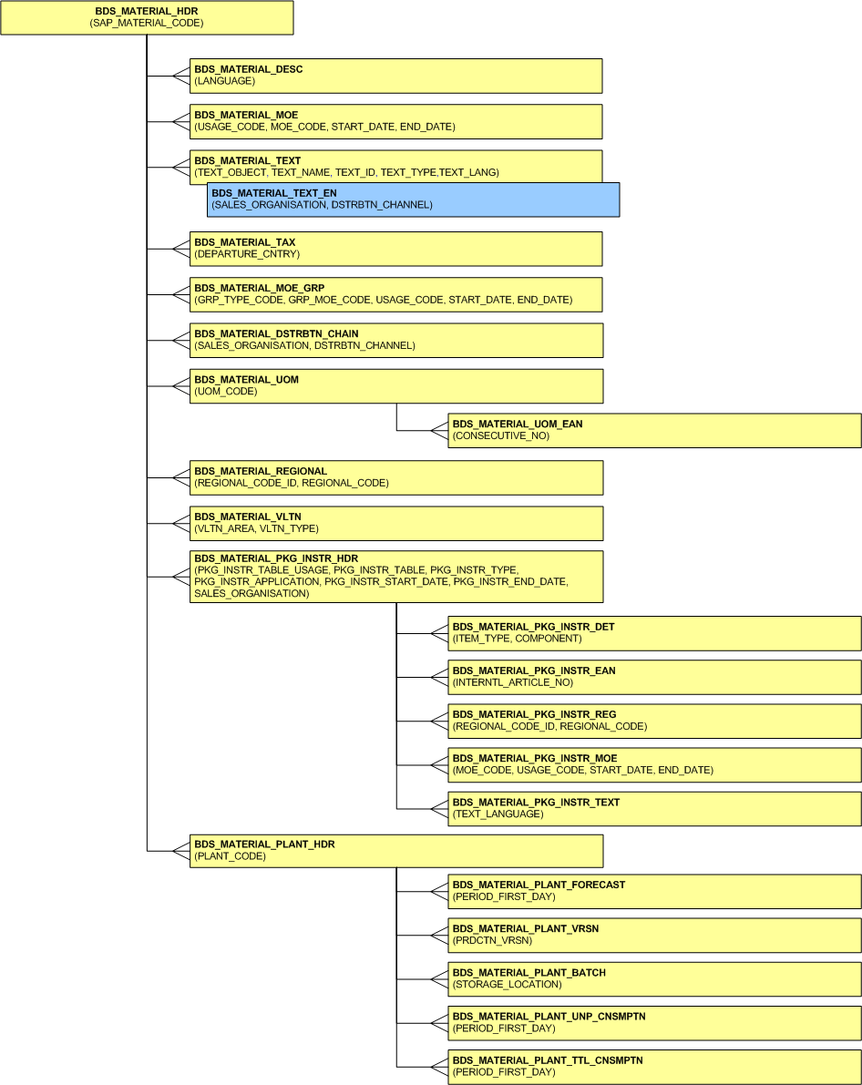
Relational Diagram

Note : the blue object indicates a varying data/primary key structure of it’s attached table.

BDS Logic

- LADS_MAT_MGN and child table LADS_MAT_MLG have been excluded from the BDS. These tables specify “Material Warehouse Numbers” by material, however, do not provide the link to the relevant Plant Code (which is a one-to-one relationship). This data set is intended for use within SAP processing only (specifically for Handling Unit functionality), and would not provide any foreseeable benefit to downstream applications based on current structure.
If this data is required at a future date, then the relevant mapping from Warehouse Number to Plant Code would need to be sent to LADS. In the event of this occurring, the BDS processing should be updated at the same time.

Tables Explained

BDS_MATERIAL_HDR – Material Header
Source LADS Tables: LADS_MAT_HDR, LADS_MAT_MKT
Filters: LADS_MAT_MKT.SPRAS_ISO = ‘EN’

Stores header level data for GRD materials, including weights, measures, material type, English description, etc.

BDS_MATERIAL_DESC – Material Description
Source LADS Tables: LADS_MAT_MKT
Filters: none

Stores material description by language. The English description (EN) is repeated on the material header – therefore, this table would only be used to retrieve non-English descriptions.

BDS_MATERIAL_MOE – Material Mars Organisational Entity
Source LADS Tables: LADS_MAT_MOE
Filters: none

Stores MOE data by valid date range. BDS Date standards apply to date ranges.

BDS_MATERIAL_TEXT – Material Sales Text
Source LADS Tables: LADS_MAT_TXH, LADS_MAT_TXL
Filters: none

Stores sales text by ‘TEXT_NAME’ (Sales Area) and language. The English ‘MVKE‘ only records are repeated in BDS_MATERIAL_TEXT_EN, which should be used unless non-English or non-MVKE records are required.

BDS_MATERIAL_TEXT_EN – Material English MVKE Sales Text
Source LADS Tables: LADS_MAT_TXH, LADS_MAT_TXL
Filters: LADS_MAT_TXH.SPRAS_ISO = 'EN',
LADS_MAT_TXH.TDOBJECT = 'MVKE',
LADS_MAT_TXH.TDTEXTTYPE = 'ASCII'

Stores sales text by distribution channel and sales organisataion. When accessing sales text, this table should be used, unless non-English or non-MVKE values are required (in which case the BDS_MATERIAL_TEXT table should be used).

BDS_MATERIAL_TEXT_ZH – Material Chinese MVKE Sales Text
Source LADS Tables: LADS_MAT_TXH, LADS_MAT_TXL
Filters: LADS_MAT_TXH.SPRAS_ISO = 'ZH',
LADS_MAT_TXH.TDOBJECT = 'MVKE',
LADS_MAT_TXH.TDTEXTTYPE = 'ASCII'

Stores sales text by distribution channel and sales organisataion. When accessing sales text, this table should be used, unless non-Chinese or non-MVKE values are required (in which case the BDS_MATERIAL_TEXT table should be used).

BDS_MATERIAL_TAX – Material Tax
Source LADS Tables: LADS_MAT_TAX
Filters: none

Stores taxation information by departure country.

BDS_MATERIAL_MOE_GRP – Material Mars Organisational Entity Grouping
Source LADS Tables: LADS_MAT_GME
Filters: none

Stores MOE groupings by valid date range. BDS Date standards apply to date ranges.

BDS_MATERIAL_DSTRBTN_CHAIN – Material Distribution Chain
Source LADS Tables: LADS_MAT_SAD, LADS_MAT_ZSD
Filters: none

Stores distribution chain data by Sales Organisation and Distribtuion Channel.

The MARS_LOGISTICS_POINT can be used as part of pricing calculation (within SAP). Distribution chain can be assigned a “point” which can be used to alter pricing calculations.

BDS_MATERIAL_UOM – Material Unit of Measure conversions
Source LADS Tables: LADS_MAT_UOM
Filters: none

Stores Unit of Measure conversion values.

BDS_FACTOR_TO_BASE_UOM is the division of the Numerator by Denominator. If the Denominator is null or 0, resulting value is 0. (No rounding is applied to this value).

BDS_MATERIAL_UOM_EAN – Material Unit of Measure for EAN
Source LADS Tables: LADS_MAT_UOE
Filters: none

Stores alternate EAN (International Article Numbers) by UOM code. A MAIN_EAN_INDCTR identifies the primary relationship.

BDS_MATERIAL_REGIONAL – Material Regional Code Conversions
Source LADS Tables: LADS_MAT_LCD
Filters: none

Stores Regional (or “local”) code conversions to GRD material code by Regional ID.

BDS_MATERIAL_VLTN – Material Regional Code Conversions
Source LADS Tables: LADS_MAT_MBE
Filters: none

Stores material valuation details, including standard valuations, applicable legal conditions, etc.

BDS_MATERIAL_PKG_INSTR_HDR – Material Packaging Instruction Header
Source LADS Tables: LADS_MAT_PCH, LADS_MAT_PCR, LADS_MAT_PIH
Filters: none

Stores material packaging instruction data at the header level, including valid date range of instructions and applicable sales organization.
Typically, data from this table would be accessed via the view BDS_MATERIAL_PKG_INSTR or function XXXX.

BDS_MATERIAL_PKG_INSTR_DET – Material Packaging Instruction Details
Source LADS Tables: LADS_MAT_PID
Filters: none

Stores material packaging instruction data at the detail level, including “components” that make up the material and associated quantities.
Typically, data from this table would be accessed via the view BDS_MATERIAL_PKG_INSTR or function XXXX.

BDS_MATERIAL_PKG_INSTR_EAN – Material Packaging Instruction EAN
Source LADS Tables: LADS_MAT_PIE
Filters: none

Stores EAN details by packaging instruction, including an indicator of which is the primary.

BDS_MATERIAL_PKG_INSTR_MOE – Material Packaging Instruction MOE
Source LADS Tables: LADS_MAT_PIM
Filters: none

Stores MOE details by packaging instruction, including valid date range of record.

BDS_MATERIAL_PKG_INSTR_TEXT – Material Packaging Instruction Text
Source LADS Tables: LADS_MAT_PIT
Filters: none

Stores Packaging Instruction text by language.

BDS_MATERIAL_PKG_INSTR_REG – Material Packaging Instruction Regional Code Conversions
Source LADS Tables: LADS_MAT_PIR
Filters: none

Stores Packaging Instruction conversions to regional/local codes.

BDS_MATERIAL_PLANT_HDR – Material Plant Header
Source LADS Tables: LADS_MAT_MRC
Filters: none

Stores Plant data by material and warehouse (WERKS).

BDS_MATERIAL_PLANT_FORECAST – Material Plant Forecast data
Source LADS Tables: LADS_MAT_MPM
Filters: none

Stores Plant data by material and warehouse (WERKS).

BDS_MATERIAL_PLANT_BATCH – Material Plant Warehouse & Batch data
Source LADS Tables: LADS_MAT_MRD
Filters: none

Stores batch/warehouse data by material, plant and storage location.

BDS_MATERIAL_PLANT_VRSN – Material Plant Version
Source LADS Tables: LADS_MAT_MRD
Filters: none

Stores material versioning data by version number.

BDS_MATERIAL_PLANT_UNP_CNSMPTN – Material Plant Unplanned Consumption
Source LADS Tables: LADS_MAT_MUM
Filters: none

Stores Unplanned Consumption data by plant code and first day of the period.

BDS_MATERIAL_PLANT_TTL_CNSMPTN – Material Plant Total Consumption
Source LADS Tables: LADS_MAT_MVM
Filters: none

Stores Total Consumption data by plant code and first day of the period.

BDS_MATERIAL_PLANT_MFANZ – Material/Plant for MFANZ
Source BDS Tables: BDS_MATERIAL_HDR,
BDS_MATERIAL_PLANT_HDR,
BDS_MATERIAL_TEXT_EN,
BDS_MATERIAL_REGIONAL,
BDS_MATERIAL_VLTN,
BDS_MATERIAL_UOM
Filters: BDS_MATERIAL_HDR.MATERIAL_TYPE = ROH, VERP, NLAG, PIPE or FERT
BDS_MATERIAL_PLANT_HDR.PLANT_CODE like AU% or NZ%

This is a custom table for MFANZ Plant Databases **only**. It has been created to enable Oracle Fast refresh materialised views to MFANZ Plant DBs. A select grant to this table has only been given to MANU, and should not be used by any other application.

BDS_MATERIAL_PLANT_MCH – Material/Plant for MCH
Source BDS Tables: BDS_MATERIAL_HDR,
BDS_MATERIAL_PLANT_HDR,
BDS_MATERIAL_TEXT_EN,
BDS_MATERIAL_REGIONAL,
BDS_MATERIAL_VLTN,
BDS_MATERIAL_UOM
Filters: BDS_MATERIAL_HDR.MATERIAL_TYPE = ROH, VERP, NLAG, PIPE or FERT
BDS_MATERIAL_PLANT_HDR.PLANT_CODE like CN%

This is a custom table for MCH Plant Databases **only**. It has been created to enable Oracle Fast refresh materialised views to MCH Plant DBs.

ATLLAD06 – Classification Data - (CLFMAS01)

LADS Structure

Relational Diagram
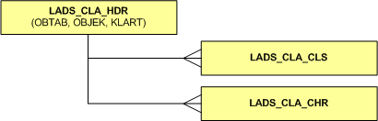

Overview
Classifications are maintained for Customer and Material data types. A data type is determined through a combination of the OBTAB (SAP Object Table) and KLART (SAP Object Key) primary key, where the values are as follows :

OBTAB | KLART | Data type
MARA | 001 | Material
KNA01 | 011 | Customer

The resulting OBJEK primary key is the relevant material/customer code.

This is reference data, and is therefore not purged from LADS.

LADS Data Logic
None applied to this interface.

BDS Structure

Relational Diagram
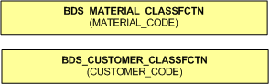

BDS Logic
- Classifications not conforming to the known data types above will NOT be flattened into the BDS. Classifications not flattened as a result of this will be updated with a LADS_FLATTENED status of 2 (Skipped/Excluded).
- LADS_CLA_CLS table data excluded from BDS. Defines SAP Classes a classification belongs to. This data is available with more detail in the ATLLAD07 interface if required.
- An individual table exists for each classification data type. Due to the different classification structures it is not possible to represent all types in a single generic manner.

Tables Explained

BDS_MATERIAL_CLASSFCTN
Source LADS Tables: LADS_CLA_HDR, LADS_CLA_CHR
Filters: OBTAB = MARA, KLART = 001

Stores characteristic value codes by material. (see ATLLAD21 for full list of characteristic codes and their descriptions). Typically this table would be accessed via the BDS_CHARISTIC_MATERIAL_EN view, which combines characteristic value codes with English descriptions.

BDS_CUSTOMER_CLASSFCTN
Source LADS Tables: LADS_CLA_HDR, LADS_CLA_CHR
Filters: OBTAB = KNA1, KLART = 011

Stores characteristic value codes by customer. (see ATLLAD21 for full list of characteristic codes and their descriptions). Typically this table would be accessed via the BDS_CHARISTIC_CUSTOMER_EN view, which combines characteristic value codes with English descriptions.

ATLLAD08 – Material BOM Data - (BOMMAT03)

LADS Structure

Relational Diagram
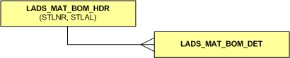

Overview
The Finished Goods Bill of Material presents the objects (or units) that make up each level of finished goods products.

This is reference data, and is therefore not purged from LADS.

LADS Data Logic
None applied to this interface.

BDS Structure

Relational Diagram
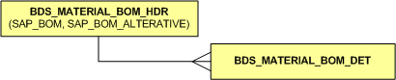

BDS Logic
- None applied to this interface.

Tables Explained

BDS_MATERIAL_BOM_HDR
Source LADS Tables: LADS_MAT_BOM_HDR
Filters: MATNR IS NOT NULL

Stores Parent level BOM data. Should never be used directly – to access Finished Goods BOM data, use either view BDS_MATERIAL_BOM_SYSDATE or BDS_MATERIAL_BOM_ALL (and function) – see Views section for more details.

BDS_MATERIAL_BOM_DET
Source LADS Tables: LADS_MAT_BOM_DET
Filters: IDNRK IS NOT NULL

Stores Child level BOM data. Should never be used directly – to access Finished Goods BOM data, use either view BDS_MATERIAL_BOM_SYSDATE or BDS_MATERIAL_BOM_ALL (and function) – see Views section for more details.

ATLLAD10 – Reference Data - (ZDISTR)

LADS Structure

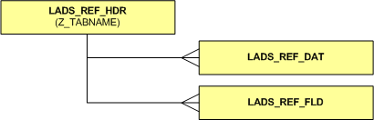
Relational Diagram

Overview
The reference data interface receives complete table extracts from SAP, where the contents of the SAP table is concatenated into a single field (LADS_REF_DAT.Z_DATA). The LADS_REF_FLD table stores field positions and lengths for breaking down the Z_DATA field. Typically the data is of a Reference nature, ie. codes and associated descriptions.

Characteristics specific note: Global characteristic data for packs, raws and finished goods should be taken from this interface (as opposed to ATLLAD21).

The Reference Tables (Z_TABNAME) contents/descriptions are as follows:

Reference Group | Reference Description | Reference Table (code)
Characteristics | Business Segment | /MARS/MD_CHC001
 | Market Segment | /MARS/MD_CHC002
 | Brand Flag | /MARS/MD_CHC003
 | Functional variety | /MARS/MD_CHC007
 | Ingredient Variety | /MARS/MD_CHC006
 | Brand Sub Flag | /MARS/MD_CHC004
 | Supply Segment | /MARS/MD_CHC005
 | Trade Sector | /MARS/MD_CHC008
 | Marketing Concept | /MARS/MD_CHC009
 | Multipack Quantity | /MARS/MD_CHC010
 | Occasion | /MARS/MD_CHC011
 | Product Category | /MARS/MD_CHC012
 | Product Type | /MARS/MD_CHC013
 | Size | /MARS/MD_CHC014
 | Consumer Pack Format | /MARS/MD_CHC015
 | Brand essence | /MARS/MD_CHC016
 | Pack type | /MARS/MD_CHC017
 | Size group | /MARS/MD_CHC018
 | Display Storage Condition | /MARS/MD_CHC019
 | Traded unit format | /MARS/MD_CHC020
 | Traded Unit configuration | /MARS/MD_CHC021
 | On-pack consumer Value | /MARS/MD_CHC022
 | On-pack consumer Offer | /MARS/MD_CHC023
 | On-pack Trade Offer | /MARS/MD_CHC024
 | Consumer Pack Format | /MARS/MD_CHC025
 | MasterFoods USA Org Level 1 | /MARS/MD_CHC026
 | MasterFoods USA Org Level 2 | /MARS/MD_CHC027
 | EFFEM Canada Org Level 1 | /MARS/MD_CHC028
 | EFFEM Canada Org Level 2 | /MARS/MD_CHC029
 | Check30 | /MARS/MD_CHC030
 | Check 31 | /MARS/MD_CHC031
 | Check 32 | /MARS/MD_CHC032
 | Check 33 | /MARS/MD_CHC033
 | Check34 | /MARS/MD_CHC034
 | Check35 | /MARS/MD_CHC035
 | Check36 | /MARS/MD_CHC036
 | Check37 | /MARS/MD_CHC037
 | FPPS Minor Pack | /MARS/MD_CHC038
 | Check39 | /MARS/MD_CHC039
 | Cuisine | /MARS/MD_CHC040
 | Check41 | /MARS/MD_CHC041
 | Check42 | /MARS/MD_CHC042
 | Check43 | /MARS/MD_CHC043
 | Check44 | /MARS/MD_CHC044
 | Check45 | /MARS/MD_CHC045
 | Check46 | /MARS/MD_CHC046
 | Check47 | /MARS/MD_CHC047
Raws / Packs | Pack Family | /MARS/MD_VERP01
 | Sub Pack Format | /MARS/MD_VERP02
 | Raw Family | /MARS/MD_ROH01
 | Raw Sub Family | /MARS/MD_ROH02
 | Raw Group | /MARS/MD_ROH03
 | Animal Parts | /MARS/MD_ROH04
 | Physical Condition | /MARS/MD_ROH05
Plant | Plant Data | T001W
Account Assignment Group | Account Assignment Group Descriptions | TVKTT
Company | Company descriptions | T001
MOE | Mars Organisational Entity descriptions | /MARS/MDMOE
Material Determination | TDU | KONDD
 | ZREP | KOTD501, KOTD907, KOTD880, KOTD002
Bill Of Material Alternate Versions | Bill of Material Alternate Versions | T415A
Vendor/Material Relationship | Vendor/Material Relationship (Purchasing Source) | EORD
Work Centers / Production Resources | Production Resource Header | CRHD
 | Production Resource Text | CRTX

This is reference data, and is therefore not purged from LADS.

LADS Data Logic
At the time of writing, this is the only LADS interface that accepts change IDOCS, as opposed to all other interfaces where a complete send of the document is expected. Hence, IDOC timestamp and IDOC number columns are available on the LADS_REF_DAT table (as well as LADS_REF_HDR).

BDS Structure

Relational Diagram
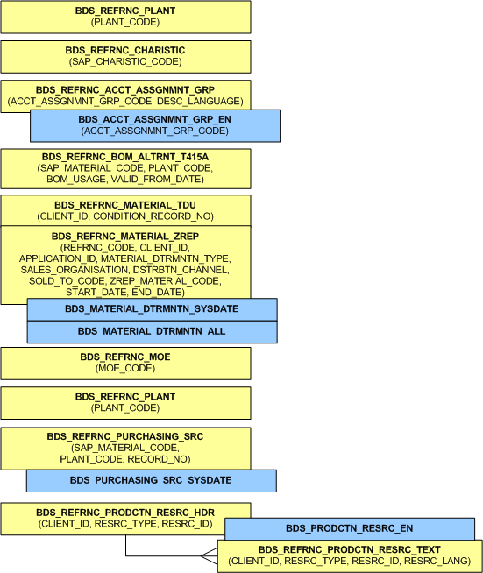

BDS Logic
See “Tables Explained” below.

Tables Explained

BDS_REFRNC_PLANT
Source LADS Tables: LADS_REF_DAT
Filters: LADS_REF_DAT.Z_TABNAME = “T001W”

Stores plant reference data by plant code.

BDS_REFRNC_ACCT_ACCT_ASSGNMNT_GRP
Source LADS Tables: LADS_REF_DAT
Filters: LADS_REF_DAT.Z_TABNAME = “TVKTT”

Stores account assignment group codes and their associated description by language. The view BDS_ACCT_ASSGNMNT_GRP_EN filters this table to only English descriptions, and should be used for this data (unless non-English descriptions are required).

BDS_REFRNC_CHARISTIC
Source LADS Tables: LADS_REF_DAT
Filters: See ATLLAD10 – LADS Overview table for Reference Group “Characteristic” for all tables included in filter.

Stores characteristic value codes, short and long descriptions by characteristic group code. This data is available by material/material type in the view BDS_MATERIAL_CHARISTIC_EN.

BDS_REFRNC_MOE
Source LADS Tables: LADS_REF_DAT
Filters: LADS_REF_DAT.Z_TABNAME = “/MARS/MDMOE”

Stores Mars Organisational Entity data by MOE Code – including long and short descriptions.

BDS_REFRNC_BOM_ALTRNT_T415A
Source LADS Tables: LADS_REF_DAT
Filters: LADS_REF_DAT.Z_TABNAME = “T415A”

Stores BOM Alternative codes by material and plant code.

BDS_REFRNC_MATERIAL_TDU & BDS_REFRNC_MATERIAL_ZREP
Source LADS Tables: LADS_REF_DAT
Filters: LADS_REF_DAT.Z_TABNAME = KONDD, KOTD501, KOTD907, KOTD880, KOTD002

Provides material determination information – ie. TDU relating to a ZREP at a given point in time (ie. by date). This data is available, already joined with necessary logic applied via views BDS_MATERIAL_DTRMNTN_SYSDATE and BDS_MATERIAL_DTRMNTN_ALL – these should be used instead of accessing the tables directly.

BDS_REFRNC_PURCHASING_SRC
Source LADS Tables: LADS_REF_DAT
Filters: LADS_REF_DAT.Z_TABNAME = “EORD”

Store a link between Material and Vendor – ie. Vendor material was purchased from. This data is keyed by valid date range. The view BDS_PURCHASING_SRC_SYSDATE provides only current relationships and should be used, unless historical or future relationships are required.

BDS_REFRNC_PRODCTN_RESRC_HDR & BDS_REFRNC_PRODCTN_RESRC_TEXT
Source LADS Tables: LADS_REF_DAT
Filters: LADS_REF_DAT.Z_TABNAME = CRHD & CRTX

Stores production resource (or work centre) information. A work centre is a piece (or group of) production line machinery within the factory. The view BDS_PRODCTN_RESRC_EN provides a join over these two tables, with descriptions filtered to EN (English) only. This view should be used, unless non-English descriptions are required.

ATLLAD11 – Customer Master Data - (DEBMAS05)

LADS Structure

Relational Diagram

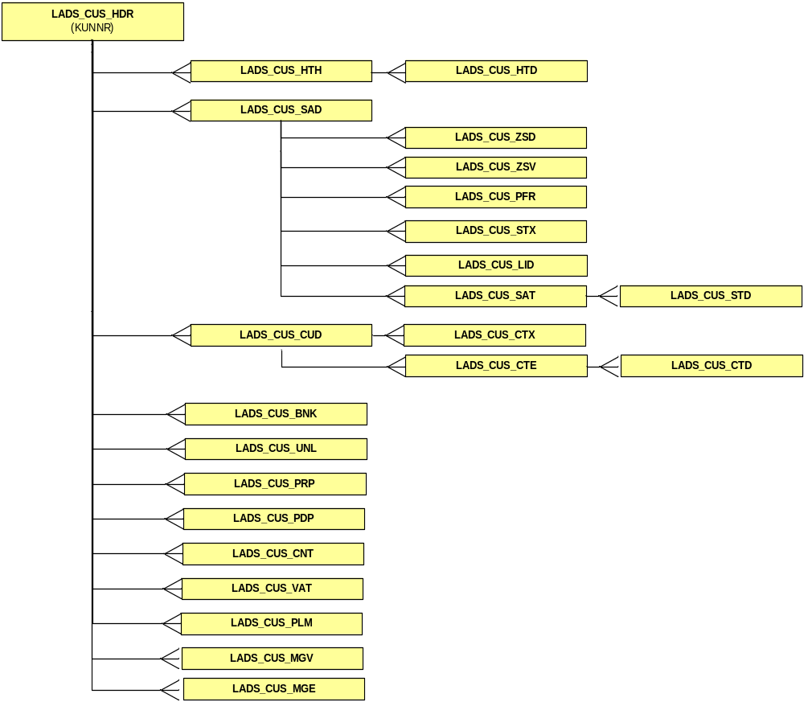

Overview
The customer master data represents the SAP customer data structure.

This is reference data, and is therefore not purged from LADS.

LADS Data Logic
None applied to this interface.

BDS Structure

Relational Diagram

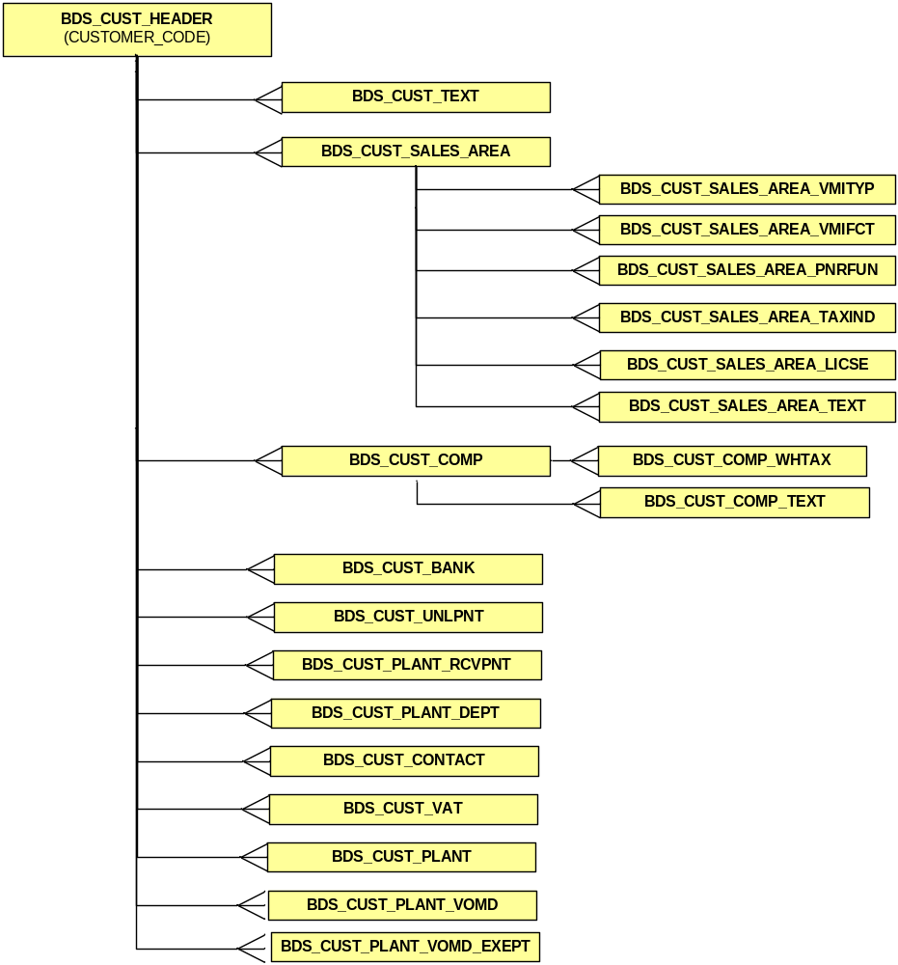

BDS Logic
- None applied to this interface.

Tables Explained

BDS_CUST_HEADER
Source LADS Tables: LADS_CUS_HDR
Filters: None

Stores customer header information.

BDS_CUST_TEXT
Source LADS Tables: LADS_CUS_HTH, LADS_CUS_HTD
Filters: None

Stores customer text information.

BDS_CUST_CONTACT
Source LADS Tables: LADS_CUS_CNT
Filters: None

Stores customer contact information.

BDS_CUST_BANK
Source LADS Tables: LADS_CUS_BNK
Filters: None

Stores customer banking information.

BDS_CUST_UNLPNT
Source LADS Tables: LADS_CUS_UNL
Filters: None

Stores customer unloading point information.

BDS_CUST_VAT
Source LADS Tables: LADS_CUS_VAT
Filters: None

Stores customer tax information.

BDS_CUST_SALES_AREA
Source LADS Tables: LADS_CUS_SAD
Filters: None

Stores customer sales area header information.

BDS_CUST_SALES_AREA_VMITYP
Source LADS Tables: LADS_CUS_ZSD
Filters: None

Stores customer sales area VMI type information.

BDS_CUST_SALES_AREA_VMIFCT
Source LADS Tables: LADS_CUS_ZSV
Filters: None

Stores customer sales area VMI forecast information.

BDS_CUST_SALES_AREA_PNRFUN
Source LADS Tables: LADS_CUS_PFR
Filters: None

Stores customer sales area partner function information.

BDS_CUST_SALES_AREA_TAXIND
Source LADS Tables: LADS_CUS_STX
Filters: None

Stores customer sales area tax indicator information.

BDS_CUST_SALES_AREA_LICSE
Source LADS Tables: LADS_CUS_LID
Filters: None

Stores customer sales area license information.

BDS_CUST_SALES_AREA_TEXT
Source LADS Tables: LADS_CUS_SAT, LADS_CUS_STD
Filters: None

Stores customer sales area text information.

BDS_CUST_COMP
Source LADS Tables: LADS_CUS_CUD
Filters: None

Stores customer company header information.

BDS_CUST_COMP_WHTAX
Source LADS Tables: LADS_CUS_CTX
Filters: None

Stores customer company withholding tax information.

BDS_CUST_COMP_TEXT
Source LADS Tables: LADS_CUS_CTE, LADS_CUS_CTD
Filters: None

Stores customer company text information.

BDS_CUST_PLANT
Source LADS Tables: LADS_CUS_PLM
Filters: None

Stores customer plant header information.

BDS_CUST_PLANT_RCVPNT
Source LADS Tables: LADS_CUS_PRP
Filters: None

Stores customer plant receiving point information.

BDS_CUST_PLANT_DEPT
Source LADS Tables: LADS_CUS_PDP
Filters: None

Stores customer plant department information.

BDS_CUST_PLANT_VOMD
Source LADS Tables: LADS_CUS_MGV
Filters: None

Stores customer plant value only material determination information.

BDS_CUST_PLANT_VOMD_EXCEPT
Source LADS Tables: LADS_CUS_MGE
Filters: None

Stores customer plant value only material determination exception information.
ATLLAD15 – Address Master Data - (ADRMAS02)

LADS Structure

Relational Diagram

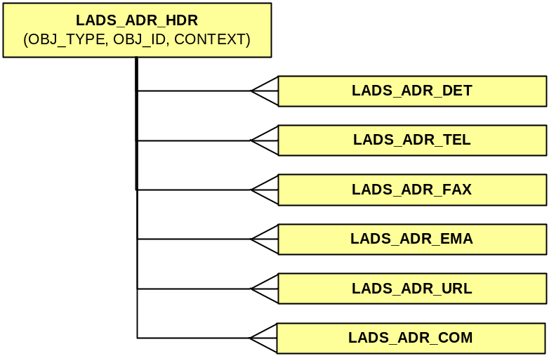

Overview
The address master data represents the address information for both customers and vendors.

This is reference data, and is therefore not purged from LADS.

LADS Data Logic
None applied to this interface.

BDS Structure

Relational Diagram

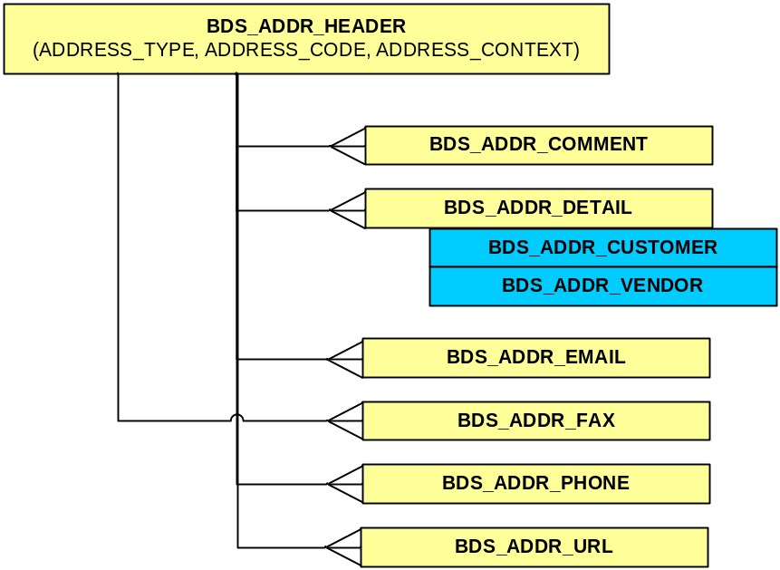

BDS Logic
- None applied to this interface.

Tables Explained

BDS_ADDR_HEADER
Source LADS Tables: LADS_ADR_HDR
Filters: None

Stores address header information. The header information indicates the type of address information – customer or vendor

BDS_ADDR_COMMENT
Source LADS Tables: LADS_ADR_COM
Filters: None

Stores address comment information.

BDS_ADDR_DETAIL
Source LADS Tables: LADS_ADR_DET
Filters: None

Stores address detail information. The detail information allows for multiple language address information to be stored.

BDS_ADDR_EMAIL
Source LADS Tables: LADS_ADR_EMA
Filters: None

Stores address email information.

BDS_ADDR_FAX
Source LADS Tables: LADS_ADR_FAX
Filters: None

Stores address fax information.

BDS_ADDR_PHONE
Source LADS Tables: LADS_ADR_TEL
Filters: None

Stores address telephone information.

BDS_ADDR_URL
Source LADS Tables: LADS_ADR_URL
Filters: None

Stores address internet address information.

BDS_ADDR_CUSTOMER
Source LADS Tables: LADS_ADR_DET
Filters: ADDRESS_TYPE = ‘KNA1’

Stores customer address detail information.

BDS_ADDR_VENDOR
Source LADS Tables: LADS_ADR_DET
Filters: ADDRESS_TYPE = ‘LFA1’

Stores vendor address detail information.

ATLLAD17 – Factory BOM Data - (LOIBOM01)

LADS Structure

Relational Diagram

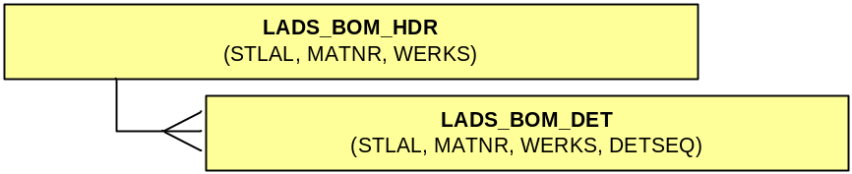

Overview
The Factory Bill of Material presents the objects (or units) that make up each level of factory manufactured products.

This is reference data, and is therefore not purged from LADS.

LADS Data Logic
None applied to this interface.

BDS Structure

Relational Diagram

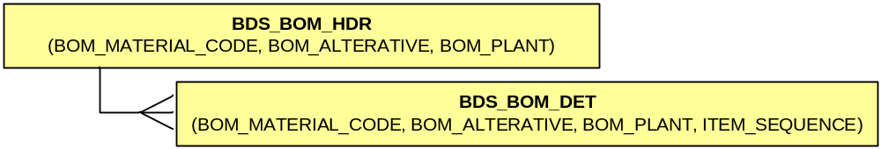

BDS Logic
- None applied to this interface.

Tables Explained

BDS_BOM_HDR
Source LADS Tables: LADS_BOM_HDR
Filters: None

Stores Parent level BOM data. Should never be used directly – to access Factory BOM data, use either function BDS_BOM.GET_DATASET or BDS_BOM.GET_HIERARCHY – see Functions section for more details.

BDS_BOM_DET
Source LADS Tables: LADS_BOM_DET
Filters: None

Stores Child level BOM data. Should never be used directly – to access Factory BOM data, use either function BDS_BOM.GET_DATASET or BDS_BOM.GET_HIERARCHY – see Functions section for more details.

ATLLAD19 – Vendor Master Data - (CREMAS04)

LADS Structure

Relational Diagram

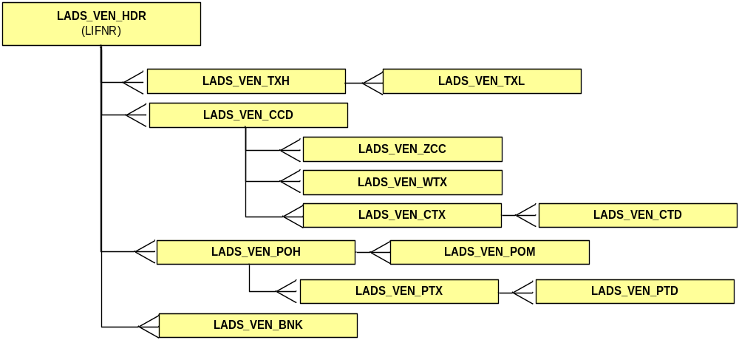

Overview
The Vendor master data represents the SAP vendor information.

This is reference data, and is therefore not purged from LADS.

LADS Data Logic
None applied to this interface.

BDS Structure

Relational Diagram
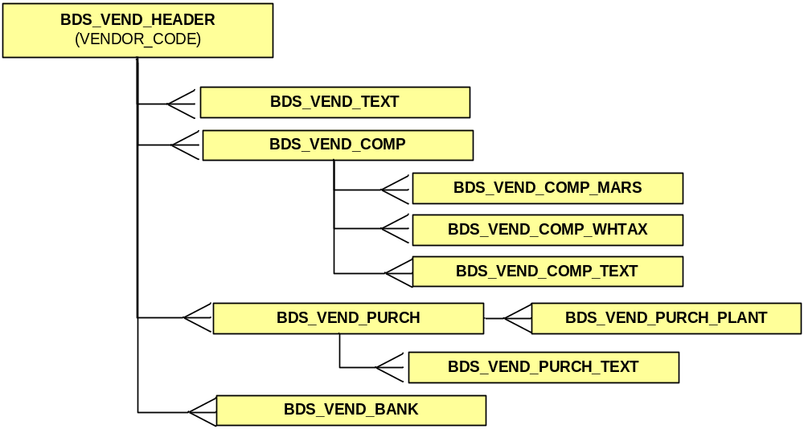

BDS Logic
- None applied to this interface.

Tables Explained

BDS_VEND_HEADER
Source LADS Tables: LADS_VEN_HDR
Filters: None

Stores vendor header level information.

BDS_VEND_TEXT
Source LADS Tables: LADS_VEN_TXH, LADS_VEN_TXL
Filters: None

Stores vendor text information.

BDS_VEND_BANK
Source LADS Tables: LADS_VEN_BNK
Filters: None

Stores vendor banking information.

BDS_VEND_COMP
Source LADS Tables: LADS_VEN_CCD
Filters: None

Stores vendor company specific information.

BDS_VEND_COMP_WHTAX
Source LADS Tables: LADS_VEN_WTX
Filters: None

Stores vendor company withholding tax information.

BDS_VEND_COMP_TEXT
Source LADS Tables: LADS_VEN_CTX, LADS_VEN_CTD
Filters: None

Stores vendor company specific text information.

BDS_VEND_COMP_MARS
Source LADS Tables: LADS_VEN_ZCC
Filters: None

Stores vendor company specific Mars bespoke in formation.

BDS_VEND_PURCH
Source LADS Tables: LADS_VEN_PCH
Filters: None

Stores vendor purchasing information.

BDS_VEND_PURCH_PLANT
Source LADS Tables: LADS_VEN_POM
Filters: None

Stores vendor plant specific purchasing information.

BDS_VEND_PURCH_TEXT
Source LADS Tables: LADS_VEN_PTX, LADS_VEN_PTD
Filters: None

Stores vendor purchasing text information.

ATLLAD21 – Characteristic Master Data - (CHRMAS03)

LADS Structure

Relational Diagram
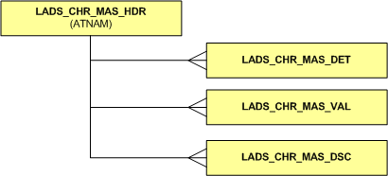

Overview
The characteristic master interface provides descriptions for characteristic values. At the time of writing, only characteristic data for Local Material and Customer characteristics were being maintained. Raws, Packs, and Global Material characteristics were being maintained as reference data and are available from ATLLAD10.

Characteristic codes and descriptions are as follows:

Characteristic Group | Characteristic Description | Characteristic Code
GLOBAL FINISHED GOODS | Business Segment | CLFFERT01
 | Market Segment | CLFFERT02
 | Brand Flag | CLFFERT03
 | Functional variety | CLFFERT07
 | Ingredient Variety | CLFFERT06
 | Brand Sub Flag | CLFFERT04
 | Supply Segment | CLFFERT05
 | Trade Sector | CLFFERT08
 | Occasion | CLFFERT11
 | Marketing Concept | CLFFERT09
 | Multipack Quantity | CLFFERT10
 | Product Category | CLFFERT12
 | Pack Type | CLFFERT17
 | Size | CLFFERT14
 | Size Group | CLFFERT18
 | Product Type | CLFFERT13
 | Traded Unit Configuration | CLFFERT21
 | Traded Unit Format | CLFFERT20
 | Display Storage Condition | CLFFERT19
 | On-pack Consumer Value | CLFFERT22
 | On-pack Consumer Offer | CLFFERT23
 | On-pack Trade Offer | CLFFERT24
 | Brand Essence | CLFFERT16
 | Consumer Pack Format | CLFFERT25
 | Cuisine | CLFFERT40
 | FPPS Minor Pack | CLFFERT38
LOCAL FINISHED GOODS | Fighting Unit | Z_APCHAR6
 | China BDT | Z_APCHAR7
 | Market Category | Z_APCHAR1
 | Market Sub Category | Z_APCHAR2
 | Market Sub Category Group | Z_APCHAR3
 | S&OP Business Code | Z_APCHAR4
 | Production Line | Z_APCHAR5
 | Planning Source | Z_APCHAR8
 | Sub Fighting Unit | Z_APCHAR9
CUSTOMERS | POS Format | CLFFERT101
 | POS Format Grouping | CLFFERT41
 | POS Format Size | CLFFERT102
 | POS Place | CLFFERT103
 | Banner | CLFFERT104
 | Ultimate Parent Account | CLFFERT105
 | Multi Market Account | CLFFERT37
 | Customer Buying Group | CLFFERT36
 | Distribution Route | CLFFERT106
 | Primary Route to Consumer | CLFFERT107
 | Operational Business Model | CLFFERT108
Raws & Packs | Raws Family | CLFROH01
 | Raws Sub Family | CLFROH02
 | Raws Group | CLFROH03
 | Animal Parts | CLFROH04
 | Physical Condition | CLFROH05
 | Pack Family | CLFVERP01
 | Packs Sub Family | CLFVERP02

This is reference data, and is therefore not purged from LADS.

LADS Data Logic
None applied to this interface.

BDS Structure

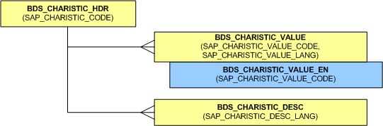
Relational Diagram

BDS Logic
- English (EN) characteristic description is repeated on the header record (if available).

Tables Explained

BDS_CHARISTIC_HDR
Source LADS Tables: LADS_CHR_MAS_HDR, LADS_CHR_MAS_DET
Filters: none

Stores header level data for characteristics, including an English description if available.

BDS_CHARISTIC_VALUE
Source LADS Tables: LADS_CHR_MAS_VAL, LADS_CHR_MAS_DSC
Filters: none

Stores characteristic value codes and associated descriptions by language. This table should only be used when a non-English (EN) characteristic value description is required – otherwise BDS_CHARISTIC_VALUE_EN is recommended.

BDS_CHARISTIC_VALUE_EN
Source LADS Tables: LADS_CHR_MAS_VAL, LADS_CHR_MAS_DSC
Filters: SPRAS_ISO = EN

Stores all available characteristic value codes for a characteristic and associated English (EN) descriptions if available. All characteristic value descriptions should be obtained from this table (unless a language other than English is required).

BDS_CHARISTIC_DESC
Source LADS Tables: LADS_CHR_MAS_DET
Filters: none

Stores a description (by language) of the characteristic – e.g. CLFFERT01 is the “Business Segment” characteristic.

ATLLAD23 – Stock Intransit - (CTL_ZOU_INTRANSIT)

LADS Structure

Relational Diagram

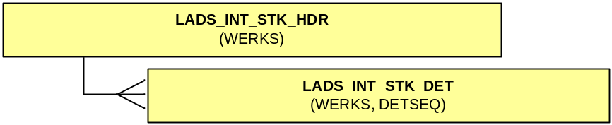

Overview
The Stock Intransit interface contains the inventory balance at a point in time for the intransit storage location.

This is replacement data, and is not purged from LADS.

LADS Data Logic
None applied to this interface.

BDS Structure

Relational Diagram

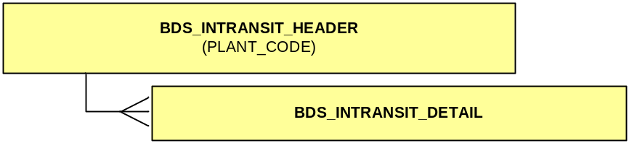

BDS Logic
- None applied to this interface.

Tables Explained

BDS_INTRANSIT_HEADER
Source LADS Tables: LADS_BOM_HDR
Filters: None

Stores Parent level Stock Intransit data. The BDS_STOCK_BALANCE view provides a consolidated view of this data with the stock balances.

BDS_INTRANSIT_DETAIL
Source LADS Tables: LADS_BOM_DET
Filters: None

Stores Child level Stock Intransit data.

BDS Views

BDS_CUSTOMER_CLASSFCTN_EN

Description
Customer classifications with associated descriptions (where available) by customer.

Source Tables
- BDS_CUSTOMER_CHARISTIC
- BDS_CHARISTIC_VALUE_EN

Filters/Logic
none

BDS_MATERIAL_CLASSFCTN_EN

Description
Material classifications with associated descriptions and type (where available) by material.

Source Tables
- BDS_MATERIAL_CHARISTIC
- BDS_REFRNC_CHARISTIC
- BDS_CHARISTIC_VALUE_EN
- BDS_MATERIAL_HDR

Filters/Logic
BDS_MATERIAL_HDR .MATERIAL_TYPE default ‘*NONE’ if not available.

BDS_ ACCT_ASSGNMNT_GRP_EN

Description
Account assignment group codes with associated English only descriptions.

Source Tables
- BDS_REFRNC_ACCT_ASSGNMNT_GRP

Filters/Logic
BDS_REFRNC_ACCT_ASSGNMNT_GRP.DESC_LANGUAGE = ‘E’

BDS_MATERIAL_BOM_SYSDATE

Description
All Material BOM data that is effective as at the current system date.

Source Tables
- BDS_MATERIAL_BOM_HDR
- BDS_MATERIAL_BOM_DET
- BDS_MATERIAL_HDR
- BDS_MATERIAL_UOM

Filters/Logic
BOM effective date is current based on sysdate (date of view execution).

BDS_MATERIAL_BOM_ALL

Description
All Material BOM data, but is to be used in conjunction with function BDS_MATERIAL.GET_MATERIAL_BOM.

Example Usage

Retrieve BOM entries for Material '000000000010027471' on date '20040914'

select *
from bds_material_bom_all t01
where t01.sap_bom = bds_material.get_material_bom('000000000010027471',null,null,null,null,to_date('20040914','yyyymmdd'));

Retrieve BOM entries for Material '000000000010027471' on sysdate (default)

select *
from bds_material_bom_all t01
where t01.sap_bom = bds_material.get_material_bom('000000000010027471',null,null,null,null,null);

BDS_BOM_ALL

Description
All Factory BOM data, for reference purposes only. Factory BOM data should always be retrieved using the BDS_BOM package functions.

Example Usage

Retrieve all BOM entries

select t01.*
from bds_bom_all t01

Source Tables
- BDS_BOM_HDR
- BDS_BOM_DET
- BDS_REFRNC_BOM_ALTRNT_T415A

Filters/Logic
None

BDS_MATERIAL_DTRMNTN_SYSDATE

Description
All Material Determination data that is effective as at the current system date.

Source Tables
- BDS_REFRNC_MATERIAL_ZREP
- BDS_REFRNC_MATERIAL_TDU

Filters/Logic
Material translation date is current based on sysdate (date of view execution).
CLIENT ID = '002'
APPLICATION ID = 'V'

BDS_MATERIAL_DTRMNTN_ALL

Description
All Material Determination data, including effective data ranges.

Source Tables
- BDS_REFRNC_MATERIAL_ZREP
- BDS_REFRNC_MATERIAL_TDU

Filters/Logic
CLIENT ID = '002'
APPLICATION ID = 'V'

BDS_MATERIAL_PKG_INSTR_SYSDATE

Description
Packaging Instruction data (Header and Detail) that is effective as at the current system date.

Source Tables
- BDS_MATERIAL_PKG_INSTR_HDR
- BDS_MATERIAL_PKG_INSTR_DET

Filters/Logic
Packaging Instruction effective date is current based on sysdate (date of view execution).
TABLE USAGE = 'P'
APPLICATION = 'PO'
TYPE = 'Z001'
TABLE = '505'
SALES ORGANISATION = '147', '149'
ITEM CATEGORY = 'I'

BDS_MATERIAL_PKG_INSTR_ALL

Description
All Packaging Instruction data (Header and Detail), including effective date ranges.

Source Tables
- BDS_MATERIAL_PKG_INSTR_HDR
- BDS_MATERIAL_PKG_INSTR_DET

Filters/Logic
TABLE USAGE = 'P'
APPLICATION = 'PO'
TYPE = 'Z001'
TABLE = '505'
SALES ORGANISATION = '147', '149'
ITEM CATEGORY = 'I'

BDS_PRODCTN_RESRC_EN

Description
Production resource/Work Centre data and their associated English descriptions.

Source Tables
- BDS_REFRNC_PRODCTN_RESRC_HDR
- BDS_REFRNC_PRODCTN_RESRC_DET

Filters/Logic
CLIENT ID = '002'
RESOURCE TYPE = 'A'
RESOURCE LANGUAGE = 'E'

BDS_ADDR_CUSTOMER_EN

Description
Customer english address data.

Source Tables
- BDS_ADDR_CUSTOMER

Filters/Logic
BDS_ADDR_CUSTOMER.ADDRESS_VERSION = ‘*NONE’.

BDS_ADDR_VENDOR_EN

Description
Vendor english address data.

Source Tables
- BDS_ADDR_VENDOR

Filters/Logic
BDS_ADDR_VENDOR.ADDRESS_VERSION = ‘*NONE’.

BDS_STOCK_BALANCE

Description
Complete stock balance position (stock and intransit).

Source Tables
- BDS_STOCK_HEADER
- BDS_STOCK_DETAIL
- BDS_INTRANSIT_HEADER
- BDS_INTRANSIT_DETAIL

Filters/Logic
BDS_STOCK_HEADER.STORAGE_LOCATION_CODE not equal ‘INTR’.

BDS Functions

Package : BDS_DATE

Function : BDS_TO_DATE ( DATE_TYPE, DATE STRING, DATE FORMAT )
Accepts a date type of *DATE, *START_DATE or *END_DATE.
Accepts a date string, ie. a valid date in valid format (e.g. YYYYMMDD, DDMMYYYY, etc.)
Accepts a date format, ie. the expected format of the date string provided.

Applies logic as per “Standards / Definitions – Date Columns” above.

BDS_MATERIAL

Function : GET_MATERIAL_BOM
This function will return the applicable STLNR (SAP_BOM) of a material if it exists.

The parameters to this function are as follows:

(par_parent_material_code in varchar2,
par_bom_plant in varchar2,
par_bom_usage in varchar2,
par_bom_status in number,
par_bom_alternative in varchar2,
par_bom_eff_date in date) return varchar2)

All parameters, with the exception of par_parent_material_code, can be passed as null and will be defaulted.

The retrieval function logic is based on the single primary key, SAP_BOM. The retrieval function defaults the SAP_BOM_ALTERNATIVE - Alternative BOM to 01(first BOM) when null is supplied.

Function : GET_UOM_CODE_CONV
This function retrieves the correct UOM Code based on the parameter supplied. stores (for example) Kilogram as KG, but builds the IDOC using KGM. The function will return the correct SAP UOM code.

Where no conversion is found, the passed in code will be returned.

(At time of writing) available conversions are as follows:

IDOC Code | SAP Code
KGM | KG
MTR | M
GRM or GM | G
LTR | L

BDS_BOM

Function : GET_DATASET
This function will return the applicable Factory BOM data based on the supplied parameters.

The parameters to this function are as follows:

(par_eff_date in date,
par_material_code in varchar2,
par_plant_code in varchar2) return bds_bom_datset

All parameters can be passed as null and will be defaulted.

This function retrieves the factory BOM dataset for the requested parameters.
- The effective date parameter defaults to sysdate when null.
- The material code parameter defaults to all materials when null.
- The plant code parameter defaults to all plant when null.
- The function should be used as follows:
  - select * from table(bds_bom.get_dataset(date,'material_code','plant_code')).

Function : GET_HIERARCHY
This function will return the applicable Factory BOM as a hierarchy based on the supplied parameters.

The parameters to this function are as follows:

(par_eff_date in date,
par_material_code in varchar2,
par_plant_code in varchar2) return bds_bom_hierarchy

All parameters, with the exception of par_ material_code and par_plant_code, can be passed as null and will be defaulted.

This function retrieves the factory BOM hierarchy for the requested parameters.
- The effective date parameter defaults to sysdate when null.
- The material code parameter must be supplied.
- The plant code parameter must be supplied.
- The function should be used as follows:
  - select * from table(bds_bom.get_hierarchy(date,'material_code','plant_code')).

